✅ Include Controller



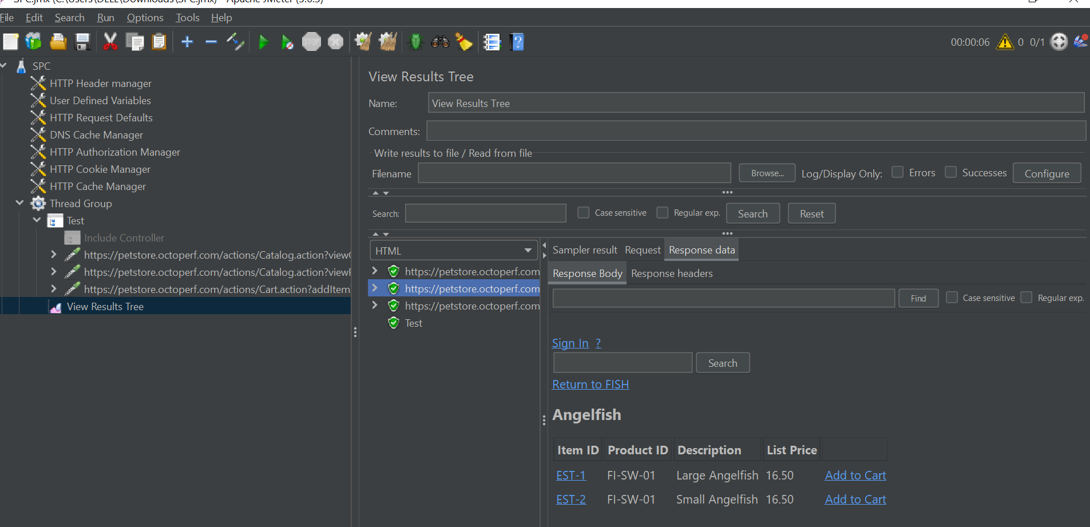

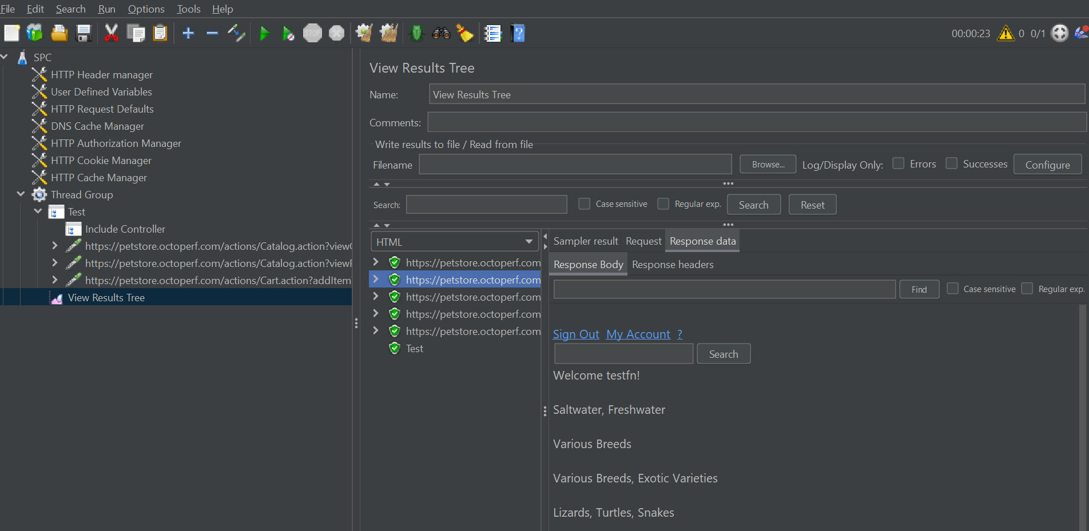

The **Include Controller** is a *Logic Controller* in Apache JMeter that lets you **insert the contents of an external .jmx test plan** (typically a reusable fragment) into your current test script. It's ideal for promoting **modular**, **reusable**, and **maintainable** test plans.

**🔧 When to Use It**

Use the Include Controller when you want to:

* Reuse common logic (e.g., login, search, logout) across multiple test plans.
* Split a large test plan into smaller, manageable parts.
* Enable multiple testers to work independently on different parts of a script.
* Simplify updates by modifying only a single source file.

**🧱 Structure Overview**

**Main Test Plan**

text

CopyEdit

Test Plan

└─ Thread Group

├─ Include Controller (Login_Module.jmx)

├─ HTTP Request (Main Scenario)

├─ Include Controller (Logout_Module.jmx)

**Fragment File (Login_Module.jmx)**

text

CopyEdit

Test Plan

└─ Test Fragment (Login Flow)

├─ HTTP Request (GET Login Page)

├─ RegEx Extractor (CSRF Token)

├─ HTTP Request (POST Login)

└─ Response Assertion

**🛠️ How to Use the Include Controller**

**✅ Step 1: Create a Test Fragment**

1. Open JMeter → Create a new Test Plan.
2. Right-click on Test Plan → Add > Test Fragment.
3. Under this fragment, build your reusable logic (e.g., login flow).
4. Save it as a .jmx file with a meaningful name (e.g., Login_Module.jmx).

💡 **Best Practice:** Use Test Fragment instead of placing logic directly under Test Plan. It avoids execution conflicts and improves clarity.

**✅ Step 2: Include Fragment in Your Main Test Plan**

1. Open the main test plan where you want to reuse the logic.
2. Right-click on a **Thread Group** or **Logic Controller** →  
   Add > Logic Controller > Include Controller.
3. In the Include Controller:
   * Set Path to JMX file to your fragment file (use relative path if possible).
   * Example: fragments/Login_Module.jmx.

**🧠 Things to Keep in Mind**

**🔁 Variable Scope**

* **Variables in Main Plan → Available in Fragment.**
* **Variables in Fragment → Not directly accessible in Main Plan.**
  + Use __setProperty() in fragment to promote to global if needed.

**📈 Listeners**

* Add **Listeners** (e.g., Summary Report, View Results Tree) in the **Main Plan**, not inside fragments.
* This ensures all sampler results, including those from included fragments, are captured.

**📂 Paths**

* **Use Relative Paths** for portability across machines.
* Example: modules/Login_Module.jmx

**⚠️ Debugging Tips**

* Save both fragment and main test plans after changes.
* Reopen main test plan to reflect fragment updates.
* Use **Debug Sampler** or **View Results Tree** to trace behavior inside fragments.

**📌 Avoid**

* Circular Includes (A includes B and B includes A).
* Complex nested includes unless absolutely needed.

**✅ Advantages Recap**

| **Benefit** | **Explanation** |
| --- | --- |
| 🔄 Reusability | Share common flows across projects |
| 🧩 Modularity | Keep scripts focused and readable |
| 👥 Collaboration | Enable parallel development |
| 🔧 Maintainability | Update one file to affect many scripts |

**📚 Real-world Use Cases**

| **Use Case** | **Example .jmx File** |
| --- | --- |
| Login Flow | Login_Module.jmx |
| DB Cleanup | DB_Teardown.jmx |
| Common Search | ProductSearchFlow.jmx |
| Checkout Flow | Checkout_Module.jmx |